Security Compliance, and Governance for AI Solutions
Strategic Guidance for Security, Governance, and Compliance
Concepts of security, governance, and compliance in organizations
- Security (Protection)
👉 Goal:
Keep data and systems safe
This includes:
- 🔒 Confidentiality → only the right people can see data
- 🛠️ Integrity → data is not changed wrongly
- ⚡ Availability → system is accessible when needed
- Governance (Decision & Control)
👉 Goal:
Make sure the organization is running properly and making good decisions
This includes:
- Policies (rules inside company)
- Risk management
- Strategy alignment
- Compliance (Following Rules)
👉 Goal:
Make sure the company follows laws, regulations, and standards
This can be:
- Government laws
- Industry standards
- Internal policies

Defense in depth
Defense in depth means using multiple layers of security instead of relying on just one.
If one layer fails, other layers are still there to protect the system.
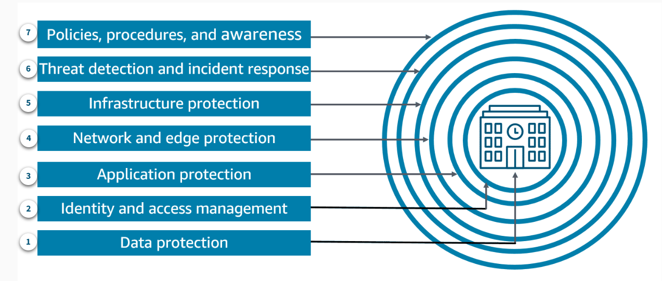
Generative AI Security Scoping Matrix
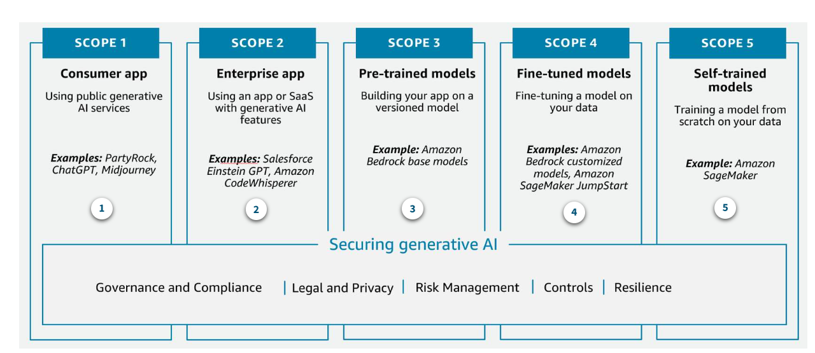
Scope 1: Consumer app
Your business consumes a public third-party generative AI service, either at no-cost or paid. At this scope, you don’t own or see the training data or the model, and you cannot modify or augment it. You invoke APIs or directly use the application according to the terms of service of the provider.
Example: An employee interacts with a generative AI chat application to generate ideas for an upcoming marketing campaign.
Scope 2: Enterprise app
Your business uses a third-party enterprise application that has generative AI features embedded within, and a business relationship is established between your organization and the vendor.
Example: You use a third-party enterprise scheduling application that has a generative AI capability embedded within to help draft meeting agendas.
Scope 3: Pre-trained models
Your business builds its own application using an existing third-party generative AI foundation model. You directly integrate it with your workload through an API.
Example: You build an application to create a customer support chatbot that uses the Anthropic Claude foundation model through Amazon Bedrock APIs.
Scope 4: Fine-tuned models
Your business refines an existing third-party generative AI foundation model by fine-tuning it with data specific to your business. This generates a new, enhanced model that is specialized to your workload.
Example: You build an application for your marketing teams that helps them build materials that are specific to your products and services. For this application you use an API to access a foundation model.
Scope 5: Self-trained models
Your business builds and trains a generative AI model from scratch using data that you own or acquire. You own every aspect of the model.
Example: Your business wants to create a model trained exclusively on deep, industry-specific data to license to companies in that industry, creating a completely novel LLM.

Understanding the data and model lineage
Source citation and documenting data origins involve providing information about the sources of the data used to train the generative AI model and the provenance of the data.
Source Citation:
Source citation in generative AI refers to the act of properly attributing and acknowledging the sources of the data used to train the model.
It is necessary to identify the sources from which the training data was collected, such as the following:
- Datasets
- Databases
- Other sources
In addition, it is necessary to identify any relevant licenses, terms of use, or permissions associated with the data.
Accurate source citation helps users and stakeholders understand the origins of the information used to generate the AI-produced content. This prepares them to assess the reliability and trustworthiness of the output.

Documenting data origins:
Documenting data origins in the context of generative AI involves providing detailed information about the provenance, or the place of origin of the data used to train the model.
This includes the following:
- Details about the data collection process
- The methods used to curate and clean the data
- Any preprocessing or transformations applied to the data
Documenting the data origins is important for understanding the potential biases, limitations, or quality issues that might be present in the training data. This can ultimately impact the performance and reliability of the generative AI model.

Tools and techniques
Data Lineage:
Data lineage is a technique used to track the history of data, including its origin, transformation, and movement through different systems.
In the context of generative AI, data lineage can be used to document the journey of the training data, from its initial sources to the final model.
This information can be used to provide detailed source citations and data origin documentation for transparency and reproducibility.
Cataloging:
Cataloging involves the systematic organization and documentation of the datasets, models, and other resources used in the development of a generative AI system.
A well-maintained catalog can serve as a comprehensive repository of information about the components of the AI system. In addition, this information can include sources, licenses, and metadata associated with the training data.
Cataloging facilitates the effective management and communication of data origins and source citations to users and stakeholders.
Model Cards:
Model cards are a standardized format for documenting the key details about an ML model, including its intended use, performance characteristics, and potential limitations.
In the context of generative AI, model cards can be used to provide source citations and data origin documentation. This helps users understand the provenance (lineage) of the data used to train the model.
Model cards can include details about the datasets used, their sources, licenses, and any known biases or quality issues in the training data.

Data engineering lifecycle
The data engineering lifecycle is an iterative process where the data is collected, prepared, and analyzed. This data is then used to train, evaluate, and continuously improve the AI or generative AI models. This lifecycle ensures that the underlying data is of high quality, representative, and optimized for the specific AI or generative AI use case. Ultimately, this process contributes to the success and performance of the AI or generative AI systems.
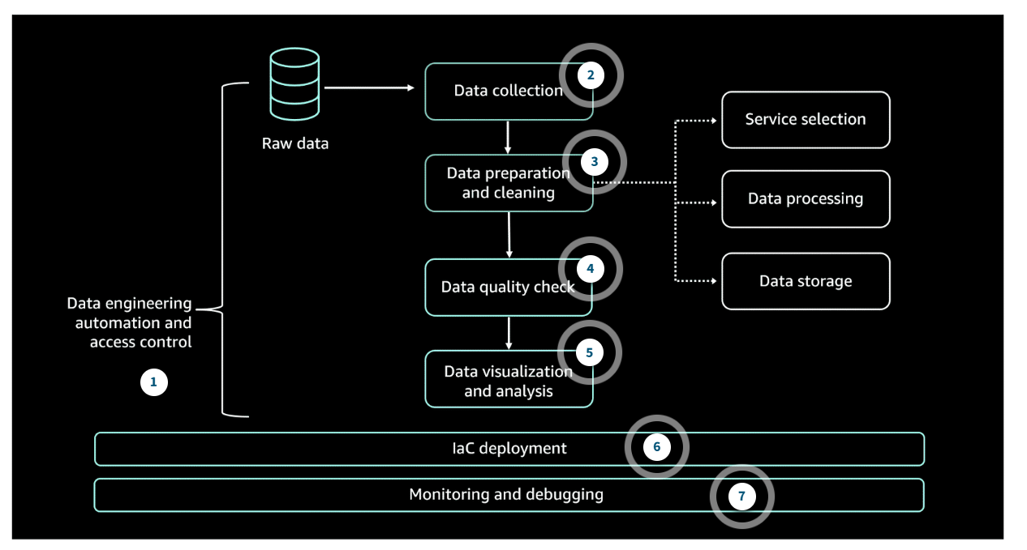
Secure data engineering
Assessing Data Quality:
Best practices for assessing the quality of data include the following:
- Define clear data quality metrics and benchmarks such as the following:
  - Completeness: Training data covers a diverse and comprehensive range of scenarios, without any significant gaps or biases.
  - Accuracy: Input data used for training AI models is accurate, up to date, and representative of the real-world scenarios the model will be applied to.
  - Timeliness: Also called currency, this measures the age of data in a data store.
  - Consistency: Maintain coherence and logical consistency of the data throughout the AI development and deployment process.
- Implement data validation checks and tests at various stages of the data pipeline.
- Perform regular data profiling and monitoring to identify data quality issues.
- Establish a feedback loop to address data quality problems and continuously improve.
- Maintain detailed data lineage and metadata to understand the origin and transformation of data.

Implementing Privacy Enhancing Technologies:
Some best practices for implementing privacy-enhancing technologies include the following:
- Implement data masking, data obfuscation (data encryption), or differential privacy mechanisms to reduce the risk of data breaches.
- Use encryption, tokenization, or secure multi-party computation to protect data during processing and storage.

Data Access Control:
The following are some best practices for controlling access to your data:
- Establish a comprehensive data governance framework with clear policies and procedures for data access, usage, and sharing.
- Implement role-based access controls and fine-grained permissions to restrict access to sensitive data.
- Use authentication and authorization mechanisms, such as single sign-on, multi-factor authentication (MFA), or identity and access management (IAM) solutions.
- Monitor and log all data access activities to detect and investigate any unauthorized access or anomalies.
- Regularly review and update access rights based on the principle of least privilege.

Data Integrity

